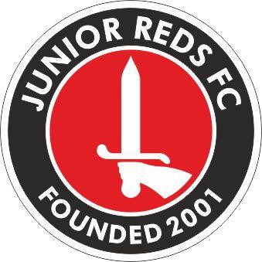

**Play your part and support the FA’s Code of Respect**

**Code of Conduct for Spectators and Parents/Carers**

**I will:**

* Have fun; it’s what we’re all here for!
* Celebrate effort and good play from both sides.
* Always respect the Referee and coaches and encourage players to do the same.
* Stay behind the touchline and within the Designated Spectators’ Area (where provided).
* When players make mistakes, offer them encouragement to try again next time.
* Never engage in, or tolerate offensive, insulting or abusive language or behaviour.

**I understand that if I do not follow the Code, I may be:**

* Issued with a verbal/Written warning.
* Required to meet with the club committee, league or CFA Welfare Officer.
* Obliged to undertake an FA education course.
* Requested not to attend future games, be suspended or have my membership removed.
* Required to leave the club along with any dependents and/or issued a fine.

The Club cannot guarantee players will receive an equal amount of time on the pitch during matches and that tactics and team selection/ substitutions by the Team Manager are final.

Remember when you are supporting the team you are representing Junior Reds. Any misconduct will bring a charge to the Junior Reds by the Football Association or League and a cost to you.

**Acknowledgement - I have read, understood and fully accept the “Code of Conduct” as required by the Junior Reds Football Club.**

Print Name……………………………….. Signature………………………….

