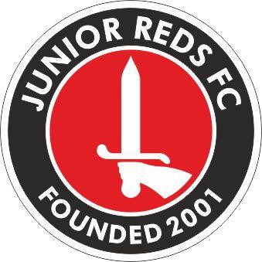

**Code of Conduct for Young Players.**

**When playing football, I will;**

* Always play my best for the benefit of my team.
* Play fairly and be friendly.
* Be on time to training and matches.
* Take proper care of my kit.
* Play by the rules and respect the Referee.
* Shake hands with the opposition - win or lose.
* Listen carefully to what my coach tells me.
* Understand the coach has to do what’s best for the team.
* Talk to someone I trust or the Club Welfare Officer if I am unhappy with something in my team or club.
* Encourage my team mates.
* Respect the facilities home or away**.**

**I Understand that if I don’t follow the code of conduct, I may;**

* Be asked to apologise to whoever I’ve upset.
* Receive a formal warning.
* Be dropped, substituted or suspended from training/matches.
* Asked to leave the club**.**

**Acknowledgement - I have read, understood and fully accept the “Code of Conduct” as required by the Junior Reds Football Club**

Print Name……………………………………………….

Signature………………………………………………….

